Assignment-3.1
Name:R.sai kundan Ht.no:2303A51413
Batch.No:21

Question 1: Zero-Shot Prompting (Palindrome Number Program) Writeazero-shotprompt(withoutprovidinganyexamples)togenerate aPythonfunctionthatcheckswhetheragivennumberisapalindrome. Task:
- RecordtheAI-generated code.
- Testthecodewithmultipleinputs.
- Identifyanylogicalerrorsormissingedge-casehandling.

Promptused:
writeapythoncodetocheckwhetheranumberisapalindromeornotusing functions, the number input should be taken from the user.
Code:
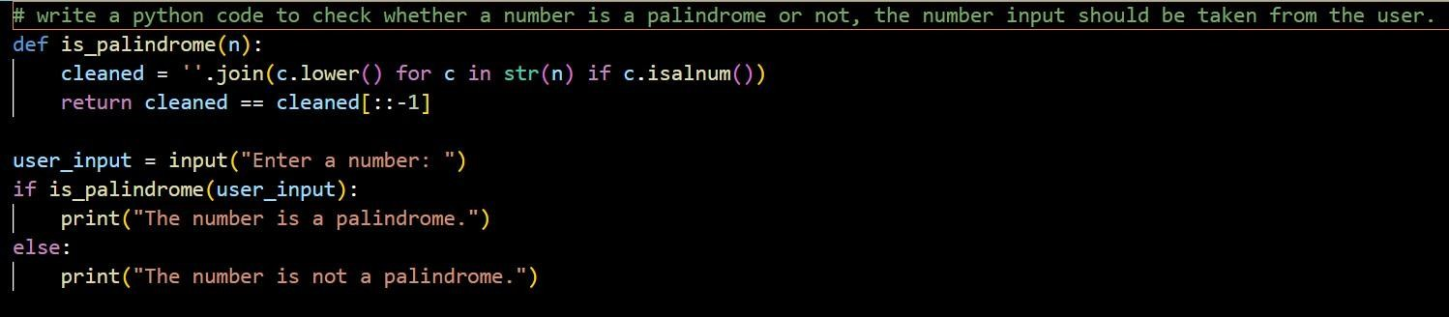

Output:

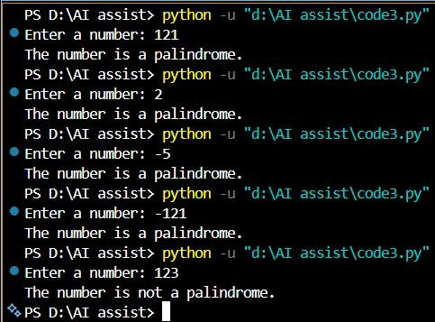

Justification:
Azero-shotpromptwasusedtogenerateaPythonprogramthatcheckswhether a number is a palindrome without providing any examples.
TheAI-generatedcodewastestedwithmultipleinputs,anditcorrectly identified positive palindromes such as 121 and 2.
However,itfailedtohandlenegativenumbersproperly,revealingamissing edge-case check in the logic.

Question2:One-ShotPrompting(FactorialCalculation)
Write a one-shot prompt byprovidingone input-output example and asktheAIto generateaPythonfunctiontocomputethe factorialofa given number.
Example:
Input:5→Output:120

Task:
- Comparethegeneratedcodewithazero-shotsolution.

- Examineimprovementsinclarityandcorrectness.

Promptused:
writeapythoncodetocalculatethefactorialofanumberusingfunctions,the number input should be taken from the user. example: input=5, output=120
Code:
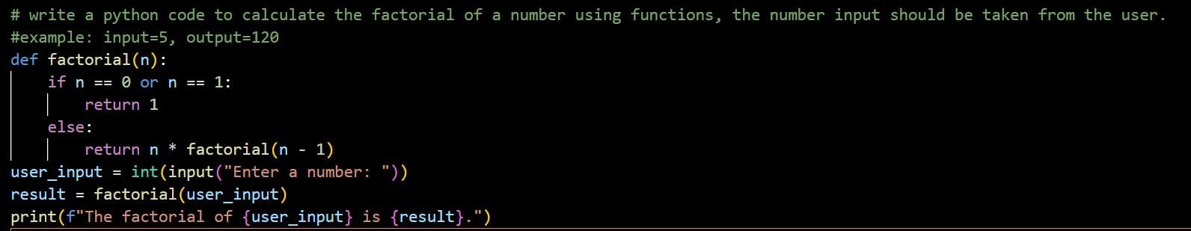
Output:
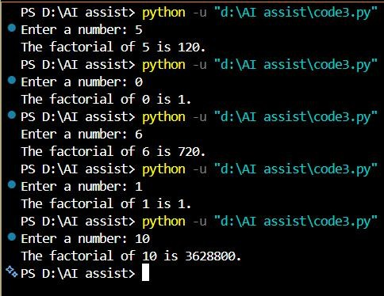

Justification:

Theone-shotpromptingapproachgeneratesclearerandmoreaccuratefactorial code by providing a sample input-output example.
ThisguidancehelpstheAIcorrectlyimplementbasecasessuchas0and1, improving correctness.
Comparedtozero-shotprompting,theone-shotsolutionismorereliableand easier to understand.

Question3:Few-ShotPrompting(ArmstrongNumberCheck)

Writeafew-shotpromptbyprovidingmultipleinput-outputexamples to guide the AI in generating a Python function to check whether a given number is an Armstrong number.
Examples:
- Input:153→Output:ArmstrongNumber
- Input:370→Output:ArmstrongNumber
- Input:123→Output:NotanArmstrongNumber

Task:
- Analyzehowmultipleexamplesinfluencecodestructureand accuracy.
- Testthefunctionwithboundaryvaluesandinvalidinputs.

Promptused:
WriteaPythoncodeusingfunctions,thatcheckswhetheragivennumberisan Armstrong number or not.
exampleTestcases:

Input:153→Output:ArmstrongNumber Input:370→Output:ArmstrongNumber
Input:123→Output:NotanArmstrongNumber

Code:
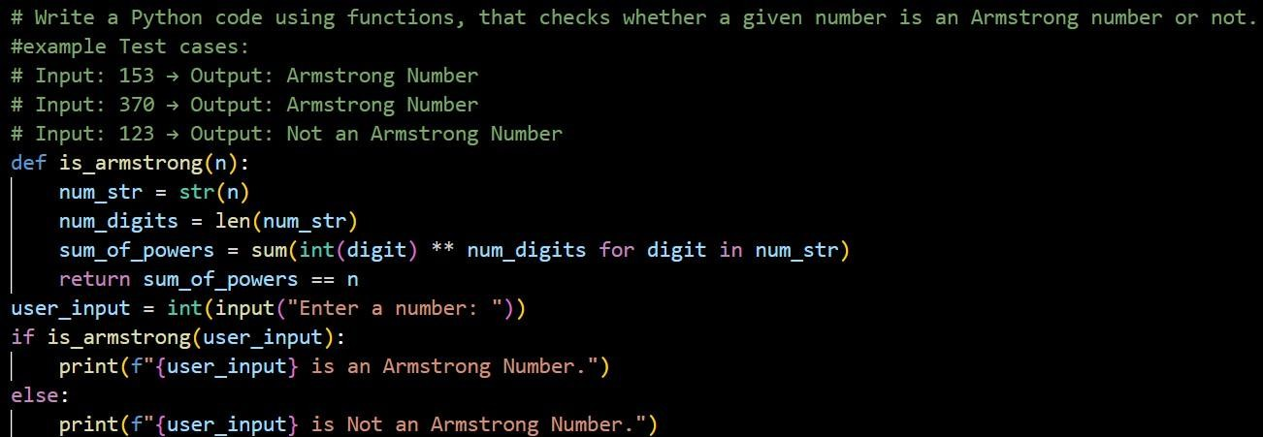

Output:

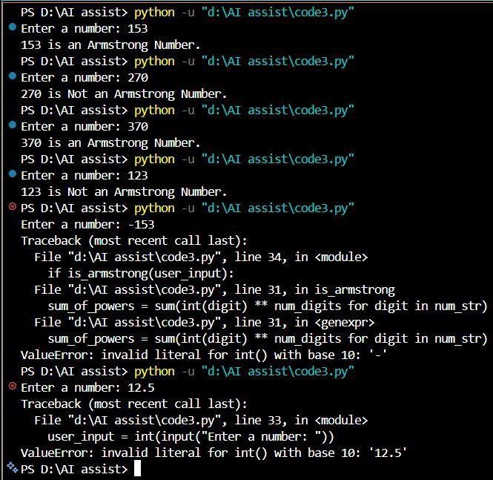

Justification:
Multipleexamplesinthe few-shot prompt help theAI clearly understand the Armstrongnumberpattern,resultinginwell-structuredandaccuratelogicfor valid inputs like 153 and 370.
Thecodecorrectlycalculatesdigitpowersbasedonthenumberofdigits, improving accuracy compared to zero-shot or one-shot prompts.
However, the program still fails for negative and non-integer inputs, showing thatfew-shotpromptingimproveslogicbutdoesnotguaranteecompleteedge- case handling.

Question4:Context-ManagedPrompting(OptimizedNumber Classification)
Design a context-managed prompt with clear instructions and constraintstogenerateanoptimizedPythonprogramthatclassifiesa number as prime, composite, or neither.
Task:
- Ensureproperinputvalidation.
- Optimizethelogicforefficiency.
- Comparetheoutputwithearlierpromptingstrategies.

Promptused:
writeanoptimizedpythonprogramthattakesainputnumberfromtheuserand classifies it as prime number, Composite number and neither prime nor composite
Constraints:
- shouldhandlenegativenumber,Zero,one,andnon-integerinputs
- useanefficientprime-checkinglogic
- keepthecodereadablewithmeaningfulvariablenamesandcomments.
- Displaytheclearresults

Code:

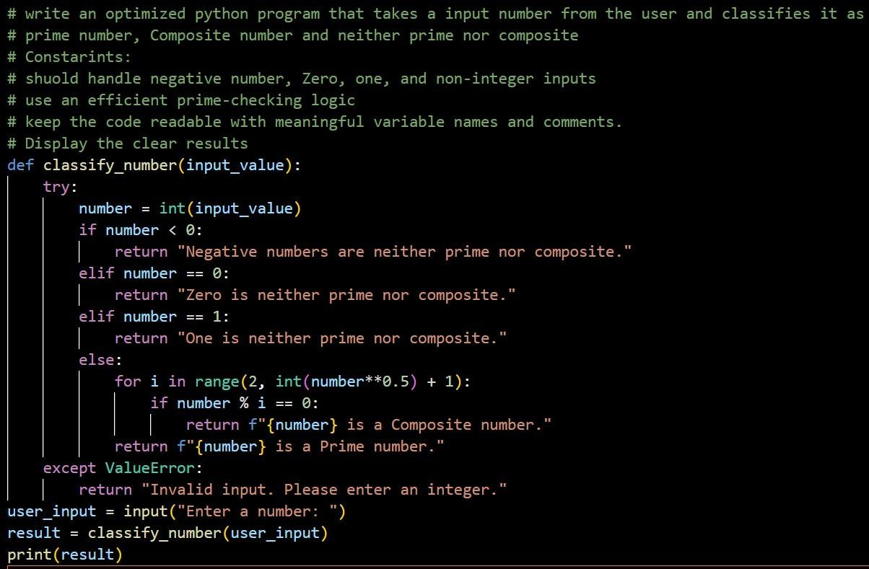
Output:
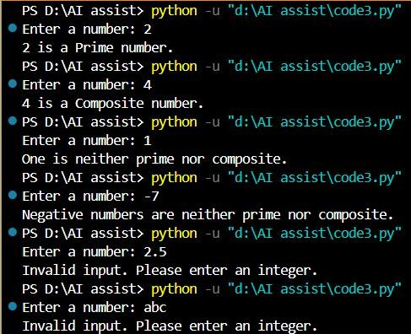
Justification:

Comparedtozero-shotandone-shotprompting,context-managedprompting produces more structured and optimized code byclearlydefining constraints and expectations.
ItimprovesinputvalidationandefficiencybyexplicitlyinstructingtheAIto handle edge cases and use optimized logic.
Overall,context-managedpromptingresultsinmorereliableandproduction- ready code than earlier prompting strategies.
Question5:Zero-ShotPrompting(PerfectNumberCheck)
Write a zero-shot prompt (without providing any examples) to generateaPythonfunctionthatcheckswhetheragivennumberisa perfect number.
Task:
- RecordtheAI-generated code.
- Testtheprogramwithmultipleinputs.
- Identifyanymissingconditionsorinefficienciesinthelogic.

Promptused:
writeapythoncodethattakenumberinputfromtheusertocheckifthenumber is perfect number or not using functions.
Code:
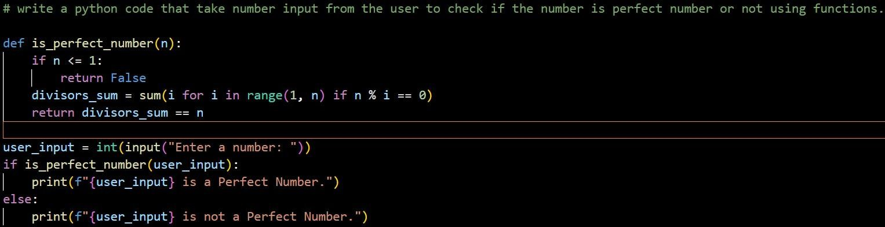

Output:
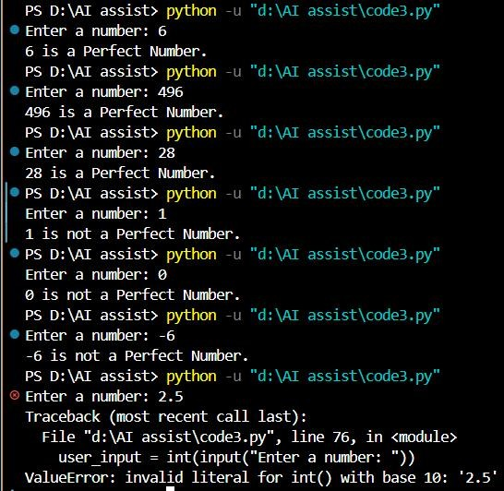

Justification:
Thezero-shotAI-generatedperfectnumberprogramlacksproperinput validation for negative and non-integer values.
Itslogicisinefficientduetounnecessaryfull-rangeiterationandmissing square-root optimization.
Theselimitationshighlighttheneedforexplicitconstraintswhenusingzero- shot prompting.
Question6:Few-ShotPrompting(EvenorOddClassificationwith Validation)

Write a few-shot prompt by providing multiple input-output examples to guide the AI in generating a Python program that determineswhetheragivennumberisevenorodd,includingproper input validation.
Examples:
- Input:8→Output:Even
- Input:15→Output:Odd
- Input:0→Output:Even

Task:
- Analyzehowexamplesimproveinputhandlingandoutput clarity.
- Testtheprogramwithnegativenumbersandnon-integerinputs.

Promptused:
WriteaPythoncodeusingfunctions,thatcheckswhetheragivennumberis Even or odd. handle negative numbers and Reject non-integer inputs
exampleTestcases:Input: 8 → Output: Even Input: 15 → Output:Odd Input: 0 → Output: Even

Code:

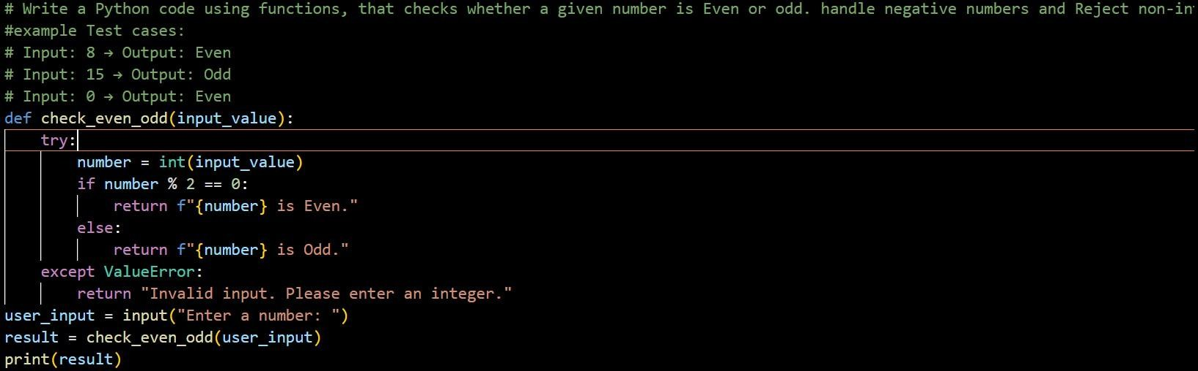
Output:
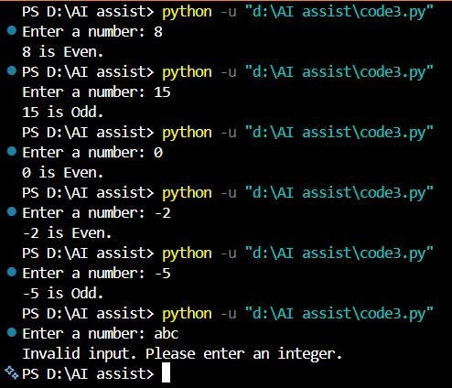
Justification:
Multipleexamplesinthefew-shotprompthelptheAIclearlyunderstandhowto classify numbers as even or odd, including boundary cases like zero.
TheexamplesguidetheAItoimproveinputhandlingbyconsideringnegative values and validating integer inputs.
Thisresultsincleareroutputmessagesandmoreaccurateclassification compared to zero-shot prompting.

